Annotations of Travel to Santiago
A manual for Expedition: The New World
Updated for v0.3.1 RC1 August 18 2011

Expedition: The New World © 2009-2011 Santiago Zapata
Design and Programming: Santiago Zapata
Graphics by: Oryx - Music by: Mingos and Jice

Prelude
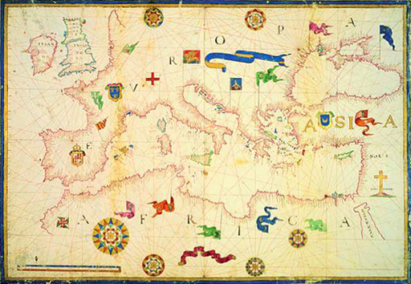
Long have I been traveling the seas of the Mediterranean, from Naples to Cyprus - from Sicily to the islands of Minorca and Majorca. I have traveled even as far as Tunizia, and the lands of the Mamelukes. I have witnessed our world changing with the passing of each equinox from the swaying boards of our ships. All my life, I have been learning.
Recently, I have seen our caravels break beyond the frontiers that had kept us bound for centuries. Our ships have gone beyond the pillars of Hercules, and far into the south. We have found the islands which we now call the Canaries, and the vast Atlantic Ocean now lays open before us.
This is a time of great changes, but my days of exploration are over... my health is declining. No longer can I even keep myself on my feet aboard a ship. My son, this is why I am leaving you all that I know; so that you can find your way in this new world.

Quickstart
I have many things to teach you my son, but if you are ever in need of finding a quick answer these tips may help you.
- The King and Queen are your benefactors, they will give you the funds necessary to outfit your expedition. Return to them when you succeed in your voyage. They will continue their patronage as long as you bring them results.
- My old friend, the Friar Dominicus Marcus, will answer your questions if you are in need, he resides in the Alcazar of Seville.
- You can either depart for the Indies with the basic equipment given to you by the Crown, or you can outfit your expedition on your own. Only do the latter when you have gained some experience from a successful voyage.

The Beginning of a Dream
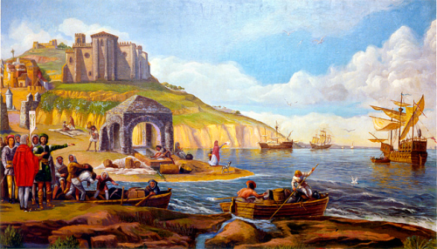
The Portuguese get closer every year to finding an African route to the Indies. They have mapped half the coast of that unknown land of jungle and desert, and they have established outposts to strengthen their presence. They have perfected their ships and nautical techniques. It is now only a matter of time before they reach their goal.
My son, I have seen you sitting at the docks of the port of Palos, looking west into the vastness of the Ocean. When you were a child, you once asked me what was beyond the horizon, where the ships can no longer be seen. Now history has given you a chance to find out the answer for yourself.
After a harsh war with the moors, the allied crowns of León and Castilla have consolidated their power over the Iberian lands. It is speculated that soon they will join forces and form a single, strong kingdom. It is a kingdom that will need a strong trading position if they want to stand against the other kingdoms of Europe.
It comes as no surprise then that the proposal to search for a western route into the Indies has been accepted by the King and Queen. As insane as it may sound, it is a great opportunity to gain an advantage over the Crown of Portugal.
I bless the heavens then, for giving you this chance to make this dream a reality. I hope that by now you have been granted a well equipped expedition, and that you are ready to sail to the horizon, to the west, and beyond!

The Voyage
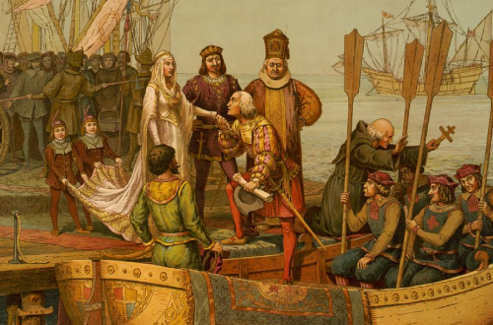
What follows comes from my experiences on the colonization of the Canary Islands, pay heed to my words, I trust they will be very useful on your journeys.
After leaving the port of Palos, you should sail south to the lands of the moors, and then southwest until you find the Canary Islands; strong southwest winds flow from there, those winds are your best chance to get somewhere far away with your ships.
Your food supply will decrease every day, so be sure you have enough in your barrels. Check the “Food Days” counter often! It tells you how many days of food you have left. While sailing, you will occasionally catch fish. However, these fish won't be enough to prevent starvation for long.
Avoid storms and repair your ships when they are under 3/4ths of their integrity. Try to sail with the wind running behind you or with it hitting your beam. In order to sail at full speed, you need a full crew for each ship. Sailors are weak in combat but you need 25 of them for each ship to achieve decent speed on adverse winds. Unfortunately, sailors can only use basic weapons (Lances and Maces, for instance)
Captains on the other hand can use stronger weapons and armor (Harquebus and Swords, and Breastplates or Studded Leather). You need one captain per ship to complete the crew.
Carpenters specialize on fixing your ships, they make more efficient use of wood during repairs, and having a healthy ship greatly increases your chances of success. They can also make buildings twice as fast as other units.

Sailing
The first you should do when leaving a port is to set your bearing and weigh anchors.
When cruising the seas, you should know well how to take advantage of the wind currents. Your ships speed is determined by its point of sail.
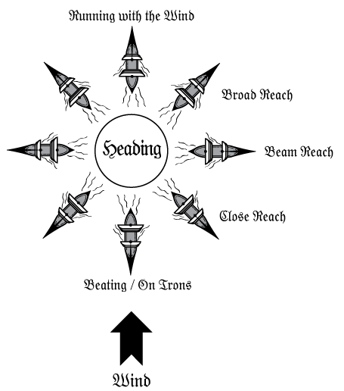
Point of Sail | Speed
Running with the Wind | Max speed for square rigged ships, the wind strength is fully used.
Wind Reach | Broad to close reach, the crew operates to make the best use of wind. Mid to low Speed.
Beating | Lowest apeed, requires all hands on board to work heavy to sail against the wind.
On Irons | The ship is stalled as sails provide no propulsion.
In addition to this, there are special maneuvers when the ship is on a storm, sails are unfurled to prevent damage and the ship sails only with the waves. The best option there is to surf the waves by heading the ship toward the wind.
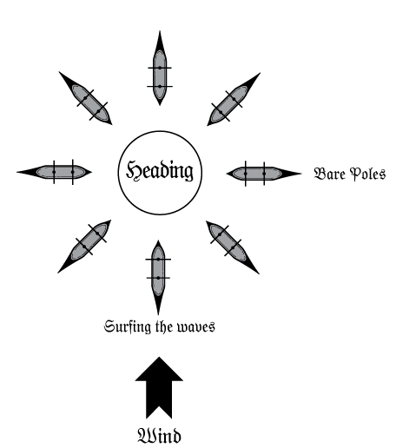

You can drop anchors any time while at sea, as long as you are close to land or shoals; this will make your ships stand by, allowing you to turn around as needed. Make sure your anchors are freed should you be trapped in a storm , else you risk your ships to be heavily damaged!
When sailing the seas, your carry capacity is determined by the capacity of all ships; all vehicles, horses and units are dead weight.
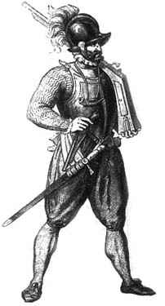

Exploring New Lands
Should your sea voyage be successful and you encounter land, you can create an exploratory expedition an venture into the unknown territories. But remember, be always prepared for unexpected situations! take enough supplies with you and, if you are not certain of the dangers that await you, bring enough protection as well.
If you expect to carry a great quantity of goods, you should also consider acquiring some horses in order to increase your cargo capacity: a horse can carry more than four times what an average human can.
You can also ride your horses if you want to transverse the land faster; in this case you will need at least as many horses as units there are in your expedition.
When exploring land, your carry capacity is determined by the capacity of all units and unmounted horses. When a horse is mounted the expedition loses its carrying capacity in exchange for mobility and attack power

Keeping the morale of your people
Having a motivated expedition can greatly influence their performance; different events may affect the general mood of your expedition, these are some situation you must look forward to prevent in order to keep your expedition in a good mood:
- Running out of supplies
- Losing too many skirmishes
- Being on the sea without touching land for too long
- Struggling against the forces of the sea or being becalmed for too long
- Having your ships in bad conditions
On the other hand, there are some events which may help you upkeep your expedition spirit:
- Having a positive balance on combat
- Having leaders in your expedition, captains and soldiers for instance
- Keeping your ships in excellent health
- Acquiring riches, including valuables and trade goods
- Having incentives such as rum for the sailing crew.
The morale of the expedition affects their performance in combat and their walking speed; it also affects how fast you can sail since your sailors will be much more active and disciplined.
The following are the positive morale statuses. Try to keep your people in them to obtain performance bonuses
Victorious | Joyous | Happy | Content | Steadfast | Calm

If enough maladies strike your people, you may go down into the negative morale statuses. Naughty things can happen as your men go desperate, try to enhance their situation to avoid problems.
Restless | Downcast | Hopeless | Cracking Apart | Depressed

The members of your Expedition
Your expedition is made up of men of different skills, and it is important to know the role of each one in order to have a successful journey.
Rogues are ruthless survivalists who will gladly take part of your adventure. They are stronger than sailors and can use swords.
Marines and Soldiers are strong, specialized warriors who are trained to fight under harsh conditions. They are the strongest men you can have on board. Marines can handle and even prefer ranged weapons like crossbows and harquebus, but they can't wear breastplates. They can also use swords and basic weapons. Soldiers, on the other hand, prefer to use swords and can wear breastplates, making them valuable on the battlefield. They can also use harquebus
Archers are light warriors trained on the use of the bow, which may be valuable in the wilderness. They can wear basic armor and they can use crossbows too.
Explorers are weak but indispensable in your journey; they extend the field of view of your expedition and that may save your life. They can only wear basic weapons
Doctors can only wear basic gear, but they help your units to heal quickly. A wounded unit can't perform its functions and is subject to die in battle, so they can be a great help in your expedition.
Finally, you can also bring colonists with you, they are people willing to strengthen the presence of the crown in foreign lands.

Foundations of a Colony
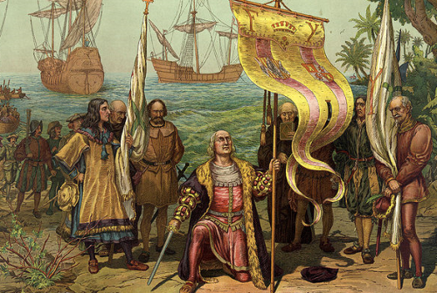
Part of your mission will be to propagate our holy faith and the flag of our King and Queen into the lands you find. You can only build colonies in lands far beyond those claimed by European and African nations.
Establishing a colony consist on executing a construction plan for a plaza and four houses, to be inhabited by up to 40 people. For such foundations you will need at least 200 pieces of wood. Remember you can chop wood from forests as long as they do not belong already to somebody.
If you have all the required resources, you will need to give a name to the new settlement. After you have established it, you can continue expanding it by executing further construction plans.
Constructing buildings costs wood and workpower; the time required to execute a construction plan depends on your expedition building capacity, where carpenters work twice as fast as the rest of units. To determine the amount of work days for a construction plan, the men-days cost of all buildings that comprises the plan will be added, and then this value will be divided into your building capacity.
Take note that even if you have a great work force, the minimum work days required for executing a construction plan is limited by the minimum work days of its buildings. For example, if you are building 2 houses and a farm, you cannot do it in less than 14 days, no matter your expeditions' building capacity.

The following is a list of buildings that you can construct in your settlements:

Building Name | Description | Wood Cost | Min. Work Days | Men Days
Settlement Plaza | Can hold 50 units of foraged food | 40 | 14 | 120
House | Can be inhabited by up to 10 people | 40 | 7 | 90
Storage Tower | Holds 300 units of foraged food | 60 | 14 | 240
Farm | Produces 5000 food each six months | 60 | 14 | 240

You can transfer people and equipment to and from the colony at any time. How many people you can transfer depends on the population capacity of the colony. The people inhabiting your settlements do not actively consume food from your inventory. However, they can make the population of your colonies grow over the time.
You can also choose to inhabit the settlement with your expedition, in which case you will stay in the town for a week without consuming food from your supplies. This can only be done if the town has enough capacity to host all the members of your expedition.

Interacting With Foreign Settlements
Should you find civilized settlements in your journey, you can interact with them in the following ways:
- Raid the Settlement: Attack the settlement, be aware that most of the times there will be hundreds of people in the settlement; however if you win a combat, their morale will be reduced and they will be subject to your threats.
- Trade Goods: You can only do this if the settlement is friendly. Pick the kind of goods you are interested in and then make an offer. The people of the settlement will evaluate it and propose you a trade. Each culture has a different appreciation for different goods. So, you may need to conduct some trading before you find their preferences. You can also ask what kind of goods they are most interested in.
- Threaten: If the people of the settlement have been intimidated by you, they will offer you goods in exchange for your mercy.
If the settlement is hostile, they will continuously send combat expedition after you.

Combat
Combat takes place when you raid a native settlement or fight a war expedition sent against yours.
Try to have at least some trained soldiers in your expedition, and be sure to buy them weapons and armor. And remember to arm your expedition and ride your mounts when its time to combat!
Combat is divided into assaults: the sixty best equipped men from each expedition will be chosen for the assault, with a maximum of 20 ranged and 20 mounted men.
An assault is divided into three phases: "Ranged", "Mounted" and "Melee", and you may suffer retaliation from the defending party during any phase.
Each phase may result in wounded or dead units. Wounded units cannot participate on the assault and are moved to the back row. Units with ranged equipment and mounted units can participate more than once on battle, during the Ranged and Mounted phases respectively. Mounted units get a bonus to their attack and defense additionally.
If the expedition rows are diminished, the wounded units will have to take part on the combat and may die on the battle. Be sure to have doctors to increase the speed at which your units rehabilitate.

Returning to Europe
The prevailing southwest winds may be a problem on your return to Europe; try sailing north until you find more suitable winds.
Prepare yourself for a dangerous voyage fraught with freezing winds and thunderous storms!
If you manage to return to Europe, you should report back to the King and Queen. They will reward you if you managed to establish colonies in foreign lands, with ranks and large sums of money to support your continued expansion.

Resources
Be sure to obtain the latest version of Expedition from http://slashware.net. Expedition is currently in constant development and evolution, so check back often!
All bug reports, comments, and requests for enhancement are welcome! If you have a bug report, or feel the game could be enhanced, please contact us! All bug reports and enhancement requests will be included in the Slashware Interactive Mantis repository.

Credits
Design and Programming: Santiago Zapata
Graphics: Oryx
MP3 Music: Contributed by “The Roguebard” http://roguebard.eptalys.net/
“The 3 Caravels” by Dominik Markzuk
“Marizápalos Oud Remasterisé” by Jice – Based on Midi version by A. Turón
“The Naive Bard (Cover)” by Dominik Markzuk
MIDI Music:
Marizápalos by A. Turón. http://www.arafolk.net/gsanz.php
Guitar version based on "Instruccion de musica sobre la gvitarra española" of Gaspar Sanz.
Musical Transcription: Ernesto Bitetti.

Appendix I: Prologo al Deseoso de Tañer
“Aunque son muchos, y grandes los Maestros que han compuesto sobre la Guitarra, assi de antiguos, como modernos, que pudieron acobardarme a sacar a luz este Tratado; no obstante, aviendo llegado a mis manos todas sus Obras, dirè mi sentir en esta materia. Unos linajudos de Instrumentos han querido buscar el solar, y genealogia a la Guitarra, y desenterrando huessos en sus instentinos sonoros, no han averiguado el intento. Solo digo, que en España es muy antiguo este Instrumento, y que el puntear en el O qualquiere otro, se usava yà en los passados siglos, pues Virgilio en sus Eneidas, pondera los primores que hazia con los dedos el Sumo Sacerdote Trayicio, diziendo:
Nec non Trayicius longa cum ueste Sacerdos.
Obloquitur numeris septem discrimina uocum,
Iamque eadem digitis, iam pectine pulsat.
En esste mi Tratado hallaràs reglas que no he visto en ninguno de los referidos Autores, porque a mas de enseñar a mutiplicar un Passacalle en veinte y quatro modos diversos, como otros han discurrido, y enseña el Doctor Carlos, aqui hallaràs forma de mayores quilates, pues sobre cada uno de los veinte y quatro Passacalles, y demàs sones, te enseñarè a que te inventes tantas diferencias como quisieres.”
Gaspar Sanz

Appendix 2: Letter of Colombus of the Discovery of the Indies
"Señor, porque sé que habreis placer de la grand victoria que Nuestro Señor me ha dado en mi viage, vos escribo esta, por la cual sabreis como en 33 días pasé a las Indias, con la armada que los Ilustrísimos Rey e Reina nuestros señores me dieron donde yo fallé muy muchas Islas pobladas con gente sin número, y dellas todas he tomado posesión por sus altezas con pregón y bandera real extendida, y no me fué contradicho. A la primera que yo fallé puse nombre San Salvador, a conmemoración de su Alta Magestal, el cual maravillosamente todo esto ha dado: los Indios la llaman Guanahani. A la segunda puse nombre la isla de Santa María de Concepción: a la tercera Fernandina: a la cuarta la Isabela: a la quinta la isla Juana, é asi a cada una nombre nuevo."
Cristobal Colón



